Bilkent University



Department of Computer Engineering

**CS319 – Object Oriented**

**Software Project**

*Project short-name: An Object Oriented Approach to Zork-Like (Text Based) Games*

Final Report

Project Group 1

Fatih Karaoğlanoğlu

Erdoğan Ege Tokdemir

Furkan Emrehan Kılıç

İpek Lale

Final Report

Dec 25, 2014

This report is submitted to the Department of Computer Engineering of Bilkent University in partial fulfillment of the requirements of the Senior Design Project course CS491/2.

Table of Contents

1 Introduction 2

2. Case Description 2

3. Requirements Analysis 3

3.1 Functional Requirements 3

3.2 Non-functional Requirements 4

3.3 Pseudo Requirements 4

3.4 Scenarios 4

3.5 Use-Case Models 5

3.6 User Interface/Screen mockups 6

4 Analysis Models 7

4.1 Object Model 7

4.1.1Domain Lexicon 7

4.1.2 Class Diagrams 7

4.2 Dynamic Models 9

4.2.1 State Chart 9

4.2.2 Sequence Diagram 10

5. System Design 11

5.1 Design Goals 11

5.2 Sub-System Decomposition 11

5.3 Architectural Patterns 12

5.4 Hardware/Software Mapping 12

5.5 Addressing Key Concerns 12

5.5.1 Persistent Data Management 12

5.5.2 Access Control and Security 12

5.5.3 Global Software Control 13

5.5.4 Boundary Conditions 13

5.5.5 Object Design Trade-Offs 13

6. Object-Design 14

6.1 Design Patterns 14

6.2 Class Interfaces 14

6.3 Specifying Contracts using OCL 35

7 Conclusion 38

References 39

Appendix 39

# 1 Introduction

Text-based games are computer games that are displayed not with computer generated images, but with plain text. The user is, thus, free to use his/her imagination alongside a storyline expressed through text. Popular in the 1970s and 1980s, text -based games have now been largely replaced by video games with graphics; one can still program a text - based game to gain familiarity with programming due to their being easy to write[1]. This project was inspired by and aims to recreate the classical text -based game “Zork” (1977) using an object-oriented approach; the aforementioned being easier to write makes it possible to emphasize the object-oriented software engineering aspect of the project by rebuilding an old game using modern tools and paradigms.

Zork was released in 1977 for the DEC PDP-10 mainframe computer family, making it one of the earliest text-based games. It is an interactive fiction computer game that was written using the MDL Programming Language [2]. Even though text -based games have largely fallen out of the market since the advancements in computer graphics, some are still being written for current platforms. Zork is played in a command -line interface, where the user is supposed to type in commands to move his/her character. The game begins near a house in a forest inside what the developers call the “Great Underground Empire” from which the player must return with wealth and victory [1].

# 2. Case Description

The main goal is to implement a text-based game using an object-oriented programming language, unlike the original Zork, written in MDL. The proposed system will resemble Zork in terms of setting and game plot, but will differ largely in terms of software structure. Objects will be used to represent the character, the map and even the parser. Several other classes such as “User” will be implemented to further realize the game in an object - oriented fashion. The “User” class will also bring along a user management system; each user will have a username and a password, which when entered will maintain an individual account for saved game files and previous scores. This system may go as far as enabling one user to challenge other users online for a higher score. The parser will in fact have a class of its own and an instance of it will be initiated every time the player hits “new game”. The entire system will reside in a class called ‘GameSystem’ which will manage instances of classes such as ‘User’, ‘Parser’ and ‘Game’. Unlike the original Zork, this game will randomly generate the environment. Thus, the player will experience a unique gameplay each time he/she starts over.

Additionally, there will be features such as ignoring some typos in commands. For example, the original Zork parser would not recognize the command “taek”, a mistyped version of the word “take”. A sophisticated parser that will also recognize prepositions and conjunctions is ideal.

The system to be developed is a text-based game. As the name of the game’s genre implies, the most important components of the game are user and game interactions since visual graphics do not exist. Written commands are the basic way to interact with the game. Unlike Zork, the game will provide flexibility for typos and case sensitivity.

The game plot will be based on survival. The game challenges a player to survive by displaying obstacles in his way such as hunger, heat and several hostile creatures. A player determines his/her score based on how well he/she can handle such situations. In addition, the player has a health rate which when drops to zero, ends the game. When the game ends, a high score table appears including the player’s name, score and total number of moves.

Points and health will be calculated based on randomly generated values for some commands such as “eat” and “drink”, thus enabling a chance factor in the game in addition to a skill factor.

# 3. Requirements Analysis

## 3.1 Functional Requirements

* + In the game there must be an instructions screen which includes the description of the game and a list of commands that the parser understands.
  + The game is controlled via mouse and keyboard.
  + The game must have a score screen that shows the player’s score.
  + The game should tolerate typos and must not be case-sensitive.
  + The game should include a “help” section.
  + The game should recognize the following commands: look, search, go, take, attack, kill, use, examine.
  + The user should be able to login to the game.
  + The user should be able to save his/her progress in the game.
  + The user should be able to load a previously saved progress.
  + The user should be able to logout.
  + The user should be able to restart at any point in the game.
  + The user should be able to save only one instance of his playing.
  + The user should be able to create a new account with a username and password.
  + The game should display a high score table.
  + The high score table should have dates, names and scores.
  + The system should show the date in this format: dd / mm / yyyy.
  + Multiple players should be able to play the game, although not simultaneously.

## 3.2 Non-functional Requirements

* + The response time for commands should be less than one second.
  + The game should be able to run on Windows, Mac and Linux systems.
  + The content of the game should be easy to understand.
  + There should be separate classes for each construction (locations, items, characters etc.) in the game to ease testability and increase flexibility of the system (working with separate classes make it easier to add features to the system)

* + The level of expertise of the user shall be basic.
  + The system should store a maximum of 10MB of data.
  + The user should have JRE installed in his system in order to run the program.
  + The user’s system should have at least 128MB of installed memory.

## 3.3 Pseudo Requirements

* 1. The project should be completed within three months.
  2. Java should be used as a programming language.
  3. The system must be a desktop application.
  4. The system must be distributable.

## 3.4 Scenarios

Overall usage

Lucy, a student at Bilkent University, has a lot of assignments and exams. She often gets bored and feels the need to play a computer game to relax; she runs the game, creates an account and starts playing. After a while, she gets bored, saves the game and quits. Later, she comes back and runs the game again. She loads her save file, and continues to play where she had left off. Eventually, she dies in the game. Then high score table appears and her score, name and time of end game appears along with other players. She then quits the game and continues with her studies.

Controls

During the game, she uses the “help” command to learn how to play the game. Then, using the commands that appear in the “help” section she moves the character and tries to survive the obstacles.

## 3.5 Use-Case Models

This diagram (Figure 1.1) shows the Use Case Model for logging in. The login operation can either return a success or a fail. The "load game" and "new game" operations follow "login".

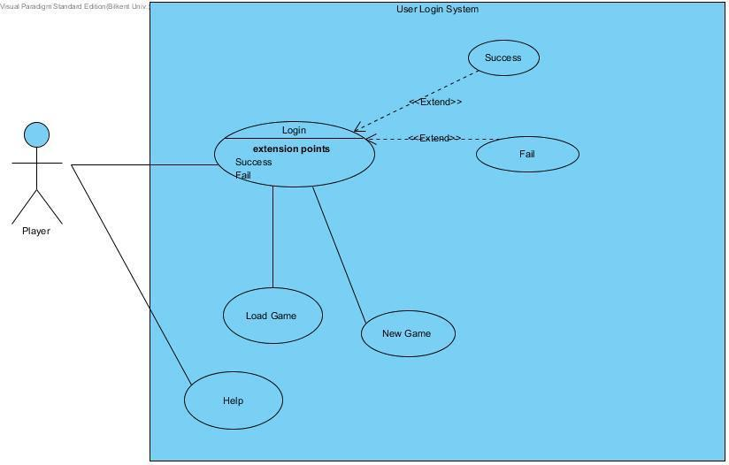

Figure 1.1

This diagram (Figure 1.2) shows the Use Case Model for a gameplay. The list of commands is as below. The entire gameplay will consist of typing commands into the command-line, some of which extend other commands.

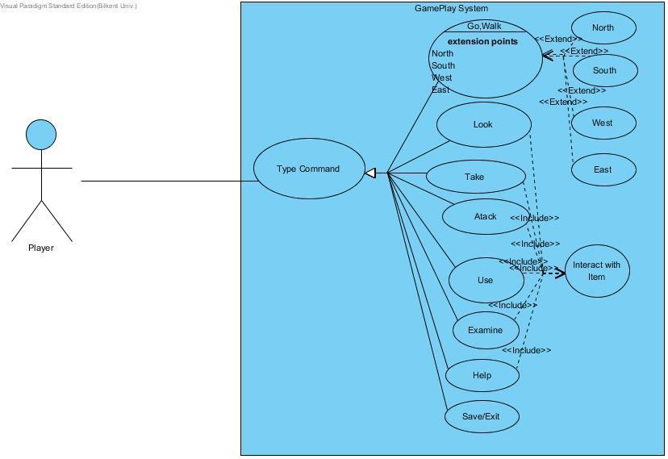

Figure 1.2

## 3.6 User Interface/Screen mockups

Below are screenshots of the system’s interface:



# C:\Users\Ege\AppData\Local\Temp\Rar$DI17.977\Capture2.PNG

# C:\Users\Ege\AppData\Local\Temp\Rar$DI18.055\Capture3.PNG

# 4 Analysis Models

## 4.1 Object Model

### 4.1.1Domain Lexicon

User: A person who plays the game

Account: Entity that is created by user with a password and user name and enables user to login the game.

Username: Entity that is created by user in order to login to the game.

Password: Entity that is created by user to encrypt his/her account.

Player: Entity that User controls in the game.

Hostile Character: Entity that is hostile against the player in the game.

Location: Locations that user can wander through in the game.

Map: Collection of Locations.

Furniture: non-movable entities in the game that user can interact.

Direction: self-explanatory

### 4.1.2 Class Diagrams

This diagram (Figure 2.1) shows the entire structure of classes and their relations. The GameSystem class, as mentioned earlier, is the class that manages all operations related to individual users. It holds an instance of "Parser" which in turn receives a Game instance as parameter. When a new game is to be started, a new instance of Game is generated inside GameSystem.

The Parser class can manage one Game object at a time. Every command entered into the terminal is delivered to the Parser object as a string, which is then interpreted in the form of a modification to the Game object. The Game object is the next class in the hierarchy and it can hold instances of several other classes such as Map and Character. Character is further divided into the Player and Non-Player Characters, which are dungeon trolls, ogres and other similar creatures the player can combat. As stated earlier, the map of the game will be randomly generated according to a seed. The map will consist of Location instances that can be thought of as coordinates linked to one another. An additional detail here is that these Location instances will represent a two dimensional plane, while some Location instances will be linked to another Location instance that resides on a completely different plane of Locations which can be accessed by "climbing up" or "climbing down" a certain structure, or Thing, inside that particular Location instance, which ultimately imitates a three dimensional environment.

Lastly, the aforementioned Thing class represents all objects available in the game, i.e items that can be acquired by the player or other stationary structures such as walls, doors, tables etc. The classes that inherit the Thing class are appropriately titled Item, which is divided further into edibles and inedibles (weapons, treasure, pamphlets etc.) via class attributes; and Furniture, both respectively modeling the previously mentioned objects in the environment.

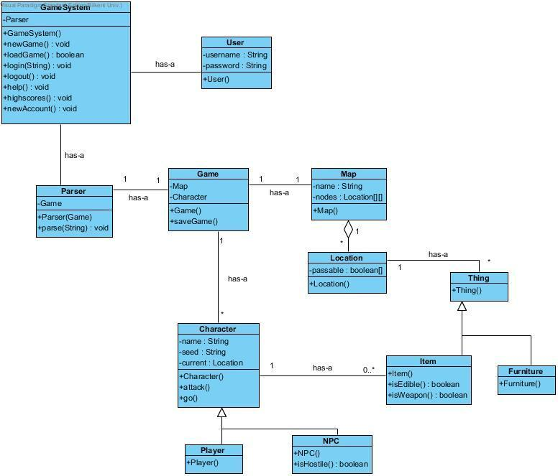

Figure 2.1

6

## 4.2 Dynamic Models

4.2.1 State Chart

This diagram (Figure 3.1) shows a State Machine Diagram that realizes the entire system. The “Parse” state models actual gameplay and the rest model the non-gameplay system.

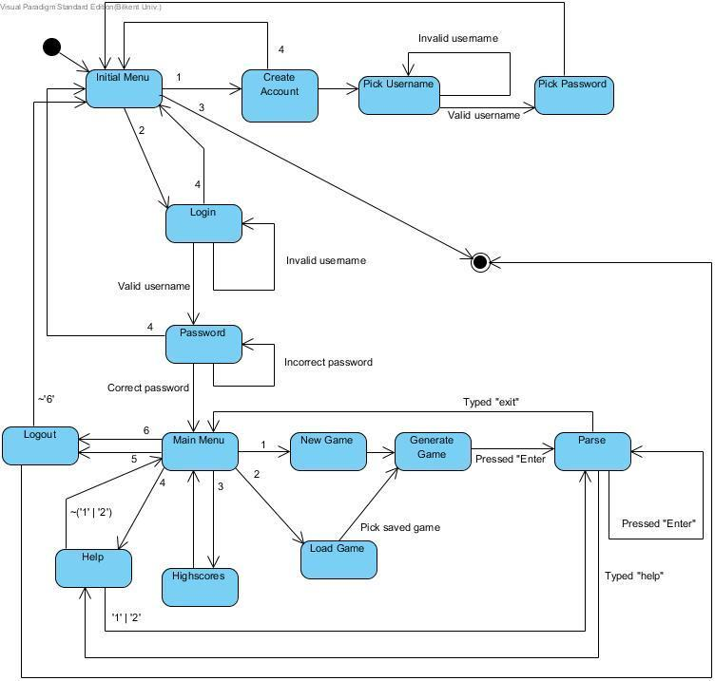

Figure 3.1

This is an additional table (Table 1) that describes the meanings of the numbers in Figure 3.1.

Table 1

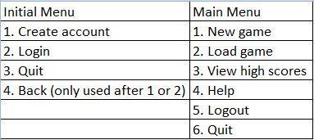

### 4.2.2 Sequence Diagram

This diagram (Figure 3.2) shows a Sequence Diagram for the saveGame() function.

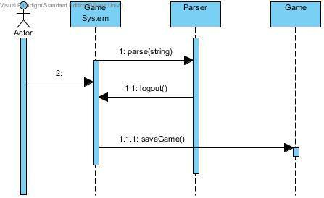

Figure 3.2

This diagram (Figure 3.3) shows a Sequence Diagram for the function startGame() which initiates a new game.

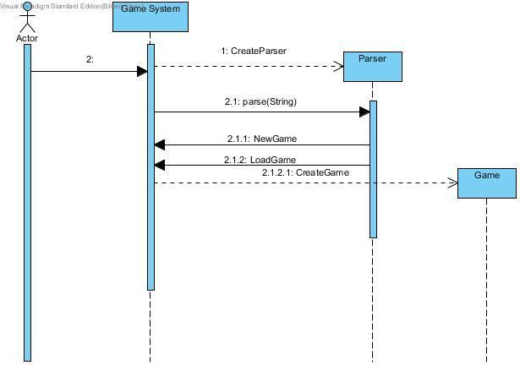

8



Figure 3.3

# 5. System Design

## 5.1 Design Goals

• Allow user to complete their task without being distracted by software or

losing train of thought

• After user types commands system responses in less than one second

• Allow user to run the system on all types of operation systems

• Give users access to information they need to complete their task (i.e.

information on other pages, etc.).

• Add clear tutorial about game to the help menu to make system easily

understandable

• System will not interrupt the game play because of the small typos of the

player

• System can be modified without changing entire structure of it

## 5.2 Sub-System Decomposition

We decided to handle our games in 5 subsystems which connect themselves

with the interactions shown in the figure. Details about subsystems and their

classes are given in the subsystem services part.



## 5.3 Architectural Patterns

## 5.4 Hardware/Software Mapping

In our project Java will be used as a programming language. Users who have enough tools to execute Java projects will be able to execute our program. Only software requirement for our system is that.

When issue comes to hardware requirements, a regular keyboard is enough.

Keyboard will be used to initialize the game, enter login information and commands to direct the game.

As a result, our project is not required an extra tool than that already exist in all computers.

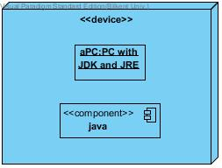

## 5.5 Addressing Key Concerns

### 5.5.1 Persistent Data Management

User information and save files will be saved as .DAT files to the hard drive. Interior of these files will be decided during implementation.

### 5.5.2 Access Control and Security

Upon creation of an account, login credentials of that account will be stored to the hard drive. When a user wants to play the game players must type in their login ID’s and passwords. If login is successful their game data will be loaded and game will start.

Otherwise they will get an error message explaining the situation. Users can access other players via a proxy and they only will be able to see their game condition and scores.

### 5.5.3 Global Software Control

The control flow that is used in this project is the event-driven control because it is the one that is most appropriate for an object-oriented programming language, such as Java. The main loop of the program is going to take an external event as input, in this case, the commands that the user enters. This is a fairly simple control flow, but our design does in fact require threads for maintaining Location instances.

Threads will become necessary for the generation of Location instances. A queue will maintain Location instances that are generated at the beginning of the program, and at several other points in the game. In order for the user not to experience a slow gameplay, a thread will be used for the generation of Location instances, such that Location instances will be generated whenever the number of Location instances drops below a threshold. The main loop and Location generation will run on different threads.

### 5.5.4 Boundary Conditions

Initializaton

Since Zoork does not have regular .exe or such extension, it will not require

any installation. Game will be initialized via a .jar file.

Termination

Because of the necessity of saving, game must be terminated with exit

command otherwise system will not be able to save and store game data and will lose the process achieved since last save.

Error

In the case of the corruption of the data system will not be able to recover the data and all processes will be lost.

### 5.5.5 Object Design Trade-Offs

This section defines the different tradeoffs in object design and the need to make decisions about them. In the making of a text-based computer game, aspects such as memory usage, availability, durability and maintainability are important. Compromises need to be made from these in order to come up with the optimal design.

• Memory space vs. response time

Text-based games often need a good share of memory even though no graphics are involved.

As more memory is required to store all the user’s data, response time may deteriorate; this,

however, should not happen. The management classes involved in sending and receiving

data, in turn, take care of this problem by limiting data transfer to only when it is required.

• Buy vs. build

Usually, a build policy may be sought because of the simple design of most objects. The

parser component, however, may be supplied from elsewhere, which will in fact save time.

The compromises needed to be made here is between cost and time, and one component

may be bought if the cost is not too high, and if it will save time.

• Platform dependence vs. flexibility

The game needs an optimal platform, such as the operating system and even architecture.

This optimal platform will allow perfect programmability for the game, but it also needs to be

flexible, such that only subtle changes to the design will grant it new platform dependency

properties. Most games in the market are optimized for one platform, however since this is a

text-based game, the switch between platforms is as simple as an integrated pattern.

# 6. Object-Design

## 6.1 Design Patterns

We have decided to use these design patterns: singleton, command and

## 6.2 Class Interfaces

a)game Package

1.**public** abstract class Character



Properties

**private**String name:

This is name of the Character

This property is **private**because it is only intended to access by setter and getter Methods provided

**private**Location current:

This is the current location of the Character

This property is **private**because it is only intended to access by setter and getter Methods provided

**private**List<Item> items:

This is the list of items that character has

This property is **private**because it is only intended to access by setter and getter Methods provided

**private int**hitpoint:

Remaining hit-points of the Character

This property is **private**because it is only intended to access by setter and getter Methods provided

Constructors

**public**Character( String name,List<Item> inventory,int x,int y); **@param**name String name to assign to character**@param**inventory List of Items Character has**@param**x Location of the Character

**@param**y Location of the Character

name and inventory will be initialized. current Location of the Character will be set according to x and y

Methods

**public**String attack(Character target,Item item);

Player attacks given target with the given item if it is possible, result given with an appropriate **String**message Damage will be calculated according to users stats, and equipment This method designed to be called from Player object inside Game object inside Parser object game.player.attack(character,item);

**@param**target to Attack

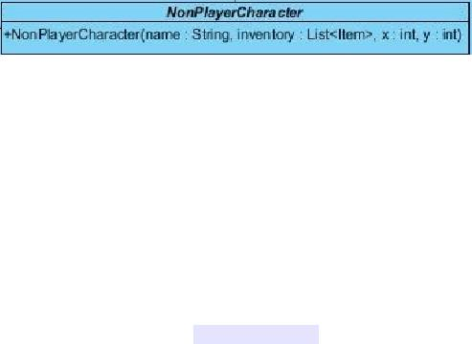

**@param**Item to use while attacking

**public**String getName();

Getter method for the property name

**@return**name as a String

**public**Location getLocation();

Getter method for the property Location

**@return**current Location of the Character

**public**List<Item> getItems()

Getter method for the property items

**@return**items as a List<Item> object

**public**int getHitPoints()

Getter method for the property hitpoint

**@return**hitpoint Integer

2.**public**abstract class NonPlayerCharacter extends Character

Constructors

**public**NonPlayerCharacter( String name,List<Item> inventory,int x,int y); **@param**name String name to assign to character

**@param**inventory List of Items Character has**@param**x Location of the Character **@param**y Location of the Character

This will call the super Constructor with the given parameters

3.**public**class HostileCharacter extends NonPlayerCharacter

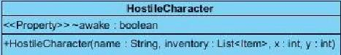

Properties

**private**boolean awake:

this boolean shows that hostile character is aware of the presence of the player, and it will attack to player with the each action player does.

This property is **private**because it is only intended to access by setter and getter Methods provided

Constructors

**public**NonPlayerCharacter( String name,List<Item> inventory,int x,int y); **@param**name String name to assign to character

**@param**inventory List of Items Character has**@param**x Location of the Character **@param**y Location of the Character

This will call the super Constructor with the given parametersMethods

Methods

**public**boolean getAwake()

Getter method for the property awake

**@return**awake as a boolean

**public**void setAwake(boolean newAwake)

Setter method for the property awake

sets the awake boolean accordingly

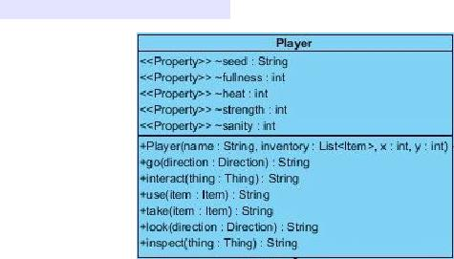

4.**public**class Player extends Character

Properties

**private**String seed:

This is the seed of the Player, all randomness will be according to this value, this way players will be able to challenge other players on same generation, also they will be able to play to play on the same world again

This property is **private**because it is only intended to access by setter and getter Methods provided

**private int**fullness:

This is the hunger level of the Player, it is designed as fullness to make it parallel with other stats, this number will decrease with every action player does, when it hits zero player will starve

This property is **private**because it is only intended to access by setter and getter Methods provided

**private int**heat:

This is the heat level of the player, this will change according to surrounding temperature. Player is forced to find some heat source in order to survive nights

This property is **private**because it is only intended to access by setter and getter Methods provided

**private int**strength:

This is the strength stat of the player, this number will act as a multiplier when calculating the damage output of his/her atacks. Player's strength may increase according to tasks done, or decrease with hunger, etc.

http://www.htmlpublish.com/newTestDocStorage/DocStorage/2c628f1ecdd345b391e71e0930a8a0b6/designReportFinal_images/designReportFinal20x1.jpg

This property is **private**because it is only intended to access by setter and getter Methods provided

**private int**sanity:

This is the sanity level of the player, It will decrease in dark (night,dungeons,etc.) and will increase if player has no hunger, heat problem during daytime. If this number goes too low, game will be over

This property is **private**because it is only intended to access by setter and getter Methods provided

Constructors

**public**Player(String name, List<Item> inventory, int x, int y); **@param**name String name to assign to Player**@param**inventory List of Items Player has

**@param**x Location of the Player**@param**y Location of the Player

This will call the super Constructor with the given parameters

Methods

**public**String go(Direction direction);**@param**direction to move

**@return**resulting String message

Player moves according to given direction if it is possible

**public**String interact(Thing thing);

**@param**thing to interact

**@return**resulting String message

Player interacts with given Thing if it is possible

**public**String use(Item item);

**@param**item to use

**@return**resulting String message

Player uses given Item if it is possible

http://www.htmlpublish.com/newTestDocStorage/DocStorage/2c628f1ecdd345b391e71e0930a8a0b6/designReportFinal_images/designReportFinal21x1.jpg

**public**String take(Item item);

**@param**item to take

**@return**resulting String message

Player takes given Item if it is possible, if successful Item will be added to players inventory.

**public**String look(Direction direction);

**@param**direction to look

**@return**resulting String message

Player looks to given direction if it is possible

**public**String inspect(Thing thing);

**@param**thing to inspect

**@return**resulting String message

Player inspects given thing if it is possible,Reader will understand look Thing, as inspect Thing

**public**String getSeed();**@return**seed as String

Getter method for the property seed **public**void setFullness(int fullness);

**@param**fullness to set

Setter method for the property fullness **public**int getFullness();

**@return**fullness as int

Getter method for the property fullness

**public**void setHeat(int heat);**@param**heat to set

Setter method for the property heat**public**int getHeat();

**@return**heat as int

Getter method for the property heat

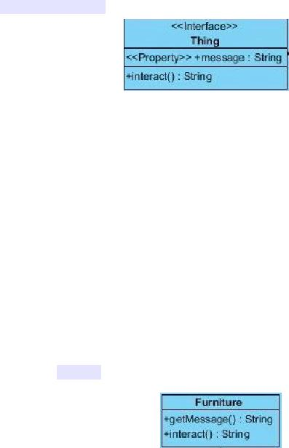

**public**void setStrength(int strength);**@param**strength to set

Setter method for the property strength **public**int getStrength();

**@return**strength as int

Getter method for the property strength

**public**void setSanity(int sanity);**@param**sanity to set

Setter method for the property sanity**public**int getSanity();

**@return**sanity as int

Getter method for the property sanity

5.**public**interface Thing

Methods

**public**String getMessage();

**@return**String message to be displayed

This Methods returns the message to be send when interacted with the object itself

**public**String interact();

**@return**String message to be displayed

A method to interact with the Thing

6.**public**class Furniture implements Thing

Methods

**public**String getMessage();

**@return**String message to be displayed

This Methods returns the message to be send when interacted with the object itself

Methods

**public**String interact();

**@return**String message to be displayed A method to interact with the Furniture

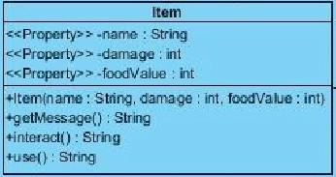

7.**public**class Item implements Thing

Properties

**private**String name:

This is name of the Item

This property is **private**because it is only intended to access by setter and getter Methods provided

**private int**damage:

If Item is a weapon this will get a positive value and it will be used to calculate output damage of the Character attacks. If it is zero this means it is not a weapon

This property is **private**because it is only intended to access by setter and getter Methods provided

**private int**foodValue:

If Item is a food this will get a positive value and it will be edible and this food will increase the fullness of the Player by the value of it

This property is **private**because it is only intended to access by setter and getter Methods provided

Constructors

**public**Item( String name,int damage,int foodValue);

Methods

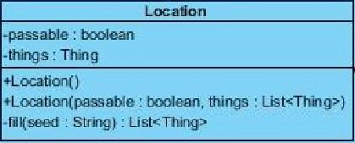

**public**String getMessage();

**@return**String message to be displayed

This Methods returns the message to be send when interacted with the object itself

Methods

**public**String interact();

**@return**String message to be displayed

A method to interact with the Furniture

**public**String use()

**@return**String message to be displayed

This method is called when Item is used

**public**String getName();**@return**name as String

Getter method for the property name

**public**int getDamage();**@return**damage as int

Getter method for the property damage

**public**int getFoodValue();**@return**foodValue as int

Getter method for the property foodValue

7.**public**class Location

Parameters

http://www.htmlpublish.com/newTestDocStorage/DocStorage/2c628f1ecdd345b391e71e0930a8a0b6/designReportFinal_images/designReportFinal26x1.jpg

**private**boolean passable;

Indicates if Location is passable, can be changed as Boolean[3] passable,

to indicate directions from this location depending of the implementation

This property is **private**because it is only intended to access by setter and getterMethods provided

**private**List<Thing> things;

List of Thing's inside this location, will be randomly generated if location is new, while loading it will be generated according to given List

This property is **private**because it is only intended to access by setter and getterMethods provided

Constructors

**public**Location();

This is the default Constructor which is used to generate new locations randomly

**public**Location( boolean passable,List<Thing> things);

**@param**passable boolean that designates if location is passable

**@param**things is a list of Thing objects which exist on that location object ThisConstructor is used when loading a saved game from a save file

Methods

**private**List<Thing> fill(String seed);

**@param**seed a string that manages the randomness**@return**list of Thing's that exists on that location

This method randomly fills a location according to a seed. This **private**method called when object is constructed with default Constructor.

8.**public**class LocationFactory

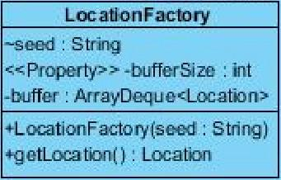

**private**String seed;

A copy of the seed of the player to manage randomness

This property is **private**because it is only intended to access by setter and getter Methods provided

**private int**bufferSize;

A designated buffer size of buffer to manage the number of Locations to keep in the ArrayDeque

This property is **private**because it is only intended to access by setter and getter Methods provided

**private**ArrayDeque<Location> buffer;

An ArrayDeque that keeps generated Locations inside. It is used as a queue in this program

This property is **private**because it is only intended to access by setter and getter Methods provided

Constructors

**public**LocationFactory(String seed);

**@param**seed as a String to manage randomness

http://www.htmlpublish.com/newTestDocStorage/DocStorage/2c628f1ecdd345b391e71e0930a8a0b6/designReportFinal_images/designReportFinal28x1.jpg

This will initialize the property seed with parameter seed

**public**void setBufferSize(int bufferSize);

**@param**bufferSize as a String to change buffer size according to needs

**public**Location getLocation();

**@return**newLocation

This method poll a Location from arraydeque and return it.

**public**void addLocation();

This method will be called when system is idle and it will fill the arraydeque with newly generated Locations

8.**public**class Map

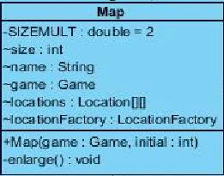

Parameters

**private**final double SIZEMULT = 2;

SIZEMULT is a **private**constant double that designates the size increase of the map when border is reached

**private int**size;

size is an **int**that shows the current size of the square map **private**String name;

This property is **private**because it is only intended to access by setter and getter Methods provided

Game game;

An instance of the game object to reach other objects in the program

**private**Location[][] locations;

A 2 dimensional array of Locations to represent the Map.

This property is **private**because it is only intended to access by setter and getter Methods provided

**private**LocationFactory locationFactory;

A LocationFactory to generate Locations when player move

Constructors

**public**Map(Game game,int initial);

**@param**game, game object passed from the caller to make it possible to reach other objects In the program

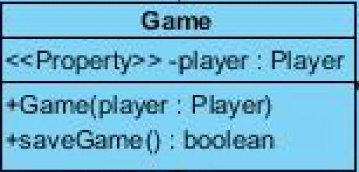

**@param**initial an integer value that shows the initial size of the square 2 dimensional Location array

Constructor sets the Properties with the parameters and initializes locations and LocationFactory

Methods

**private**void enlarge();

This method is called when player hits the borders of the existing Map, it will create a new Location[][] with the size = (size *SIZEMULT) and pass the existing locations to the middle of the new Location[][]

9.**public**enum Direction

Direction is enumeration that shows directions with the following constants in it

North,

East,

South,

West,

Upwards,

Downwards

10.**public**class Game

Parameters

**private**Player player;

An Instance of the player objects to be called from other classes that have the instance of the game object

for example game.getPlayer().go(Direction.North)

This property is **private**because it is only intended to access by setter and getter Methods provided

Constructors

**public**Game( Player player);

**@param**player is an instance of player from caller object

Constructor sets property player with parameter player

Methods

**public**Player getPlayer();

**@return**Player

returns the player object

11.**public**class GameSystem

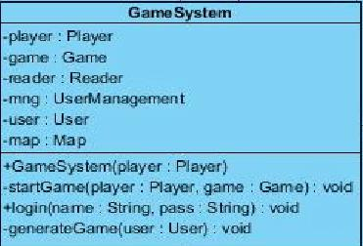

Methods of

Properties

**private**Player player;

A player object that will be generated according to User logged in

This property is **private**because it is only intended to access by setter and getter Methods provided

**private**Game game;

A Game object that will be generated according to User logged in

This property is **private**because it is only intended to access by setter and getter Methods provided

**private**Reader reader;

A Reader object which will analyze the inputs of the User and call the the player object

This property is **private**because it is only intended to access by setter and getter Methods provided

**private**UserManagement mng;

An Object that manages the login authentications

This property is **private**because it is only intended to access by setter and getter Methods provided

**private**User user;

An object that represents the user logged in and keeps its data at runtime and saves it during logout

This property is **private**because it is only intended to access by setter and getter Methods provided

**private**Map map;

A Map object which player will be wandering during playtime

This property is **private**because it is only intended to access by setter and getter Methods provided

Constructors

**public**GameSystem();

A Constructor with no parameters will initialize the UserManagement object

Methods

**private**void startGame(Player player,Game game);

**@param**player a Player object that generated according to user data

**@param**game, a Game object that generated according to user data

A **private**method that will be called when user logs in and starts the game

**public**void login(String name, String pass);

**@param**name is a String that shows the login name of the user

**@param**pass is a String that shows the login password of the user

This method will take username and password and call the authentication method of the UserManagement object. If authentication is successful it will call the generateGame method.

**private**void generateGame(User user);

**@param**user the user object that authenticated

This method will load the game according to User data, if data is empty it will randomly assign a seed and generate according to that value. After loading it will start the game.

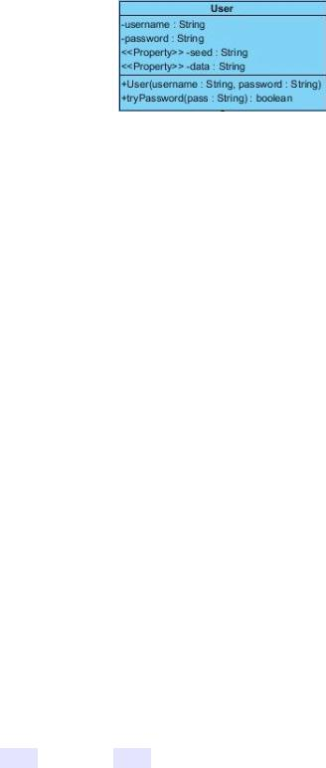

b)datamanage Package

1.**public**class User

Properties

**private**String username;

A **String**that indicates the login username of the User

This property is **private**because it is only intended to access by setter and getter Methods provided

**private**String password;

A **String**that indicates the login password of the User. This can be encrypted in order to increase security

This property is **private**because it is only intended to access by setter and getter Methods provided

**private**String seed;

A String, seed value that will guide randomness

This property is **private**because it is only intended to access by setter and getter Methods provided

**private**String data;

A String, data which will be loaded at the startup, and will be saved during exit

This property is **private**because it is only intended to access by setter and getter Methods provided

Constructors

**public**User(String username, String password);

**@param**username,that indicates the login username of the User

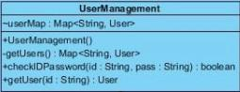

**@param**password,that indicates the login password of the User

This Constructor sets the parameter values to property values

Methods

**public**String getSeed();

**@return**seed as a String

This is the getter Method for Property seed

**public**String getData();

@ return data as a String

This is getter Method for Property data **public**boolean tryPassword(String pass)

**@param**pass a String that will be compared to password of the user **@return**boolean success of the trial

This method checks if password user entered is correct

2.**public**class UserManagement

**private**Map<String,User> userMap;

**public**UserManagement();

This Constructor takes no parameters and it fills userMap with the method getUsers()

**private**Map<String,User> getUsers();

**@return**Map<String,User> as a map of Users with names as their keys

This method reads a certain data file and fills the userMap accordingly

**public**boolean checkIDPassword(String id,String pass);

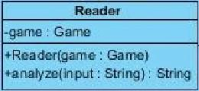

**@param**id a String that shows the id that will be tried

**@param**pass a String that shows the password that will be tried

**@return**boolean success

This method finds the user with given id and checks if pass is correct, and returns a boolean that shows the success of the authentication

**public**User getUser( String id);

**@param**id a String as the id of the User

**@return**User that found,null if User does not exists

This method looks for given id in the userMap and returns that user if it exists

c)IOManage package

1.**public**class Reader

Properties

**private**Game game;

A game object that will help Reader to reach other objects in the program

Constructors

**public**Reader(Game game)

**@param**game a simple Constructor to set property game as parameter game

Methods

**public**String analyze( String input)

**@param**input a string input that typed by the user

**@return**resulting String message to print on the screen

This Method takes a **String**input with format action receiver tool or action direction, etc. and execute the regarding Methods. After execution returns the resulting **String**to the caller

## 6.3 Specifying Contracts using OCL

context Player inv:

items->size <= MAX_NUM_ITEMS

context Player::take(item) pre:

not item = NULL

context Player::take(item) pre:

player.inventory.size() < MAX_NUM_ITEMS

context Player::take(item) post:

player.inventory.contains(item)

context Player::take(item) post:

not player.getCurrent().things.contains(item)

context Player::drop(item) pre:

player.inventory.size() > 0

context Map::enlarge() post:

size = SIZEMULT * @pre.size

context Location :: setXY(x,y) post:

self.x = x

self.y = y

context Location :: getAdjacent(d) pre:

d->passable = true

context Location :: getAdjacent(d) post:

x = @pre.x + 1

y = @pre.y + 1

context Item inv:

getDamage() >= 0

context Item inv:

getFoodValue() >= 0

context Character :: attack(c, i) pre:

c-> hitPoint >= c->strength * i->damage

context Character :: attack(c,i) post:

c-> hitPoint = @pre.(c->hitPoint - c->strength*i->damage)

context Character :: setStrength(s) pre:

s >= 0

context Character :: setStrength(s) post:

self.s = s

context Character :: setHitpoint(h) pre:

h >= 0

context Character :: setHitpoint(h) post:

self.h = h

context Furniture inv:

not getName() = NULL

context Furniture inv:

not getMessage() = NULL

context Game::setAll() pre:

allThings.isEmpty() = true

context Game::setAll() pre:

allCharacters.isEmpty() = true

context Game::setAll() pre:

allDescriptions.isEmpty() = true

context Reader::analyze(input) pre:

not input = NULL

# 7 Conclusion

This project aimed to realize an object-oriented approach towards text-based computer games, using several architectural and object design patterns, with UML as the primary language to visualize this approach. To make a true analysis of the system so that it is easily maintained and functions correctly and consistently, several models containing use cases were developed. Then, the system was decomposed to a number of subsystems, where each subsystem would maintain a unique architectural style. After the stage of object design, finally the portion of implementing the project using Java was completed.

There were many challenges faced when developing this project. Object design patterns were difficult to apply; finding the right pattern for each subsystem required a good knowledge of object design and a detailed visualization of the software to be developed. Working as a team and putting time and effort into research, we were able to manage each subsystem and apply the most appropriate patterns. Similarly, architectural patterns were not easy to implement, as it required outside-the-box thinking to fully comprehend the implications of each pattern. Again, a good deal of research made it possible to select and apply only one pattern that we deemed fit. Other obstacles such as time constraint and technical issues were always present, as is in all software development projects, and only pushed us even further to accomplish our goals.

The true triumph of building object-oriented software is to have accomplished a goal that applies to a computer, using real world solutions to solve real world problems. We believe that with the knowledge that we have gained out of this project, we are ready to explore further challenges to help solve real world problems through a fundamental understanding of the core concepts of object-oriented software engineering. As far as future work goes, it is almost a certainty that the principles that we have acquired in this project will be of guidance in many of our personal or corporate projects.

# References

[1] http://en.wikipedia.org/wiki/Zork.

[2] <http://en.wikipedia.org/wiki/Text-based_game>

# Appendix